(Approx. 1091 words)

Lots of Pictures – File Explorer to the Rescue
By Phil Sorrentino, Newsletter Contributor, Sarasota Technology Users Group
www.thestug.org
philsorr (at) yahoo.com
Everyone these days has a phone, and every phone these days has two cameras, so everyone, these days, has lots of pictures. And it seems that these days everyone has their pictures on their phone. Just ask someone about their grandchildren or pet; I bet they pull out their phone and start swiping through loads of images; some may be from five or six years ago. They may find the pictures in question, or they may not. The phone is a great way to show your photos because it is always with you. The problem is that all the pictures are on the phone, the good, the bad, and the ugly. Many are not the subject of the question of the moment. Getting to the pictures in question can be a real-time consuming activity. There’s got to be a better way. There is, but it involves a few organizational skills and a bit of stick-to-itivity. You’ve got to organize regularly so that the organization will be there when you need it. It is sort of the same logic that makes you backup all your important documents regularly.
Fortunately, Windows comes with a great file manager, File Explorer. It’s the application that has been called “the keys to the kingdom” (if you’ve taken the File Explorer class) because it lets you get into and modify your file organization by allowing you to create and delete folders. In addition, it enables you to move or copy files so you can get them into the proper folders. But the pictures are on your phone, you say. Yes, the first thing to do is get the photos from the phone to the computer, and File Explorer is the tool to use. You can connect your smartphone to your computer using a USB cable, one with a USB connector on one end and probably a micro-USB connector on the other end. If you have a very new phone, you might have to use a USB cable with a USB-type-C connector on the phone end. The micro USB ends are not compatible, so you can’t plug into the wrong slot. (Be sure that the cable is more than just a charging cable; it has to be able to transport data between devices.) There are other ways to get your pictures transferred to your computer, one of which is using the App “Wi-Fi file transfer,” which has been previously covered in a so-named article from January 2017. Another way is to use a “cloud storage” service like OneDrive or Google Drive. Just upload your pictures from your phone to your cloud of choice, and then download the pictures to your computer using your browser of choice.
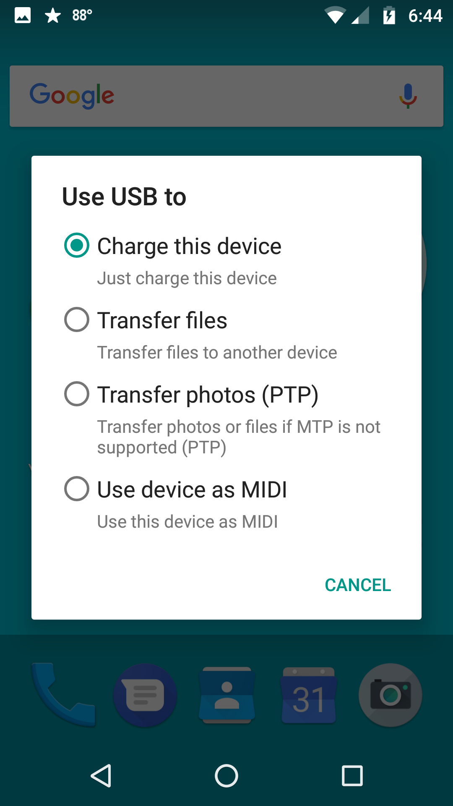 Android System Notification (select Transfer files)
Using a cable on an Android phone, you might have to change an “Android System” notification. Just pull it down from the Notification bar and tap it, then select “Transfer files,” and your phone will show up in the navigation pane of File Explorer. Next, click on internal storage, then DCIM, and finally “camera.” (On an Apple phone, it is as easy as connecting the phone to the computer with the USB cable.)

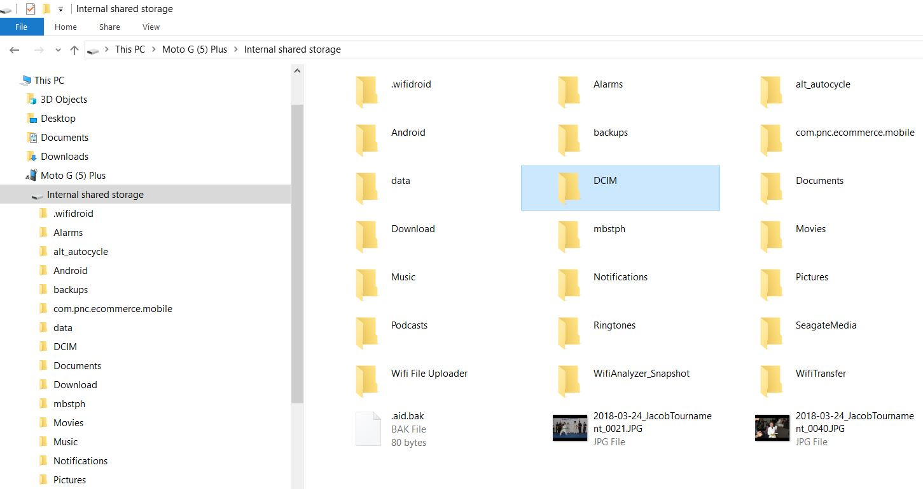 Android connected to PC
Now you should see all of the pictures that have been taken with your phone’s cameras (both landscape and selfie). They are probably titled “IMG_date code_large sequential number.jpg,” something like IMG20200810_12345678. The date code is probably the year, month, and day that the picture was taken. The date gives you a clue as to where to store the picture on your computer. The sequential number is to make sure every picture has a unique file name. Now you can move these pictures from the camera to your picture library, which may be in Pictures, but better still, it is in a high-level folder of your choice, like MyPhotos or MyPictures. (Just something other than the “well known” folder name - Pictures.) I keep my pictures in a “Slides&Photos” folder in chronological folders. Every year has its own folder, and the years are collected in decades. You can drag & drop the pictures from the camera folder to the computer folder, or you can use Copy and Paste, remember Ctl-C & Ctl-V, or right-click the picture and find Copy and Paste in the Menu. Any of these will do the job. Once the pictures are on the computer - and backed up - you can delete them from the camera, if you want, or at least delete the ones that you won’t need with you all the time.
Pictures from Camera
Now that your pictures are on the computer, you can move them into the folder organization that you have previously set up. If you haven’t set up a folder structure, think about it and decide how to organize your memories. As I alluded to earlier, I keep my pictures in chronological folders, with special folders for special memories. A chronological organization is pretty straightforward, a folder for each year collected in decades. And in each year’s folder, there will be folders for special events, like a visit to a National Park, a visit to some old friend’s new lake cottage, or a visit from old friends. Birthdays and Holidays can also have their own folders, which are named with dates and events like “19-07FourthOfJulyParty”. The date in the title guarantees that the folders will be kept in chronological order (remember that File Explorer keeps items in alpha-numeric order, numbers first, then letters).
Even though most of my folder organization is in chronological order, I have special folders for special memories. For example, I have special folders for many, not all, of my extended family (Aunts, Uncles, Cousins) and folders for special friends (i.e., Jim&Terry). This organization lets me review the pictures of these people quickly because they are all together in one folder (these are typically copies from the chronological folder). On the other hand, pictures are always in chronological order because I put the date in the file name when I transferred the image to the computer, for example, 2019-07-04FourthOfJulyAtBill&Nancy. (Including the date in the file name takes some extra time, but I have found that it is worth the time in the long run.) Picture folder organization is a very personal choice, but once you have yours set up, File Explorer will help you easily maintain it, even if you have tens for thousands of pictures.

